Lab Objective

Configuring DFS Namespace

**Lab Procedures**

**1.** On Server01, open File Explorer and create **C:\Share1** and **C:\Share2** folders.

**2.** Right-click Share1 and click Properties. The Properties dialog box opens.

**3.** Click the Sharing tab and click Advanced Sharing.

**4.** Click Share this folder check box.

**5.** Click Permissions. Click Allow Full Control for Everyone. Click OK to close the Permissions dialog box.

|  |  |
| --- | --- |
| Question 1 | Because we allow everyone full control, how do you make sure that the shared files are secure? Back up all the time |

**6.** Click OK to close Advanced Sharing dialog box and click Closeto close the Share1 Properties dialog box.

**7.** On Server01, repeat the process to share Share2.

**8.** On Server02, open File Explorer and create **C:\Share1** and **C:\Share2** folders.

**9.** Similar to what was done on Server01, share theShare1 and Share2 on Server02.

**10.** On Server01, with Server Manager, click Tools > DFS Management to open the DFS Management console.

**11.** In the left-pane, right-click Namespaces and select New Namespace. The New Namespace Wizard starts.

**12.** On the Namespace Server page, type **Server01** in the Server text box. Click Next.

**13.** On the Namespace Name and Settings page, type **Shares** in the Name text box.

**14.** Click Edit Settings. The Edit Settings dialog box opens as shown in Figure 4-1.

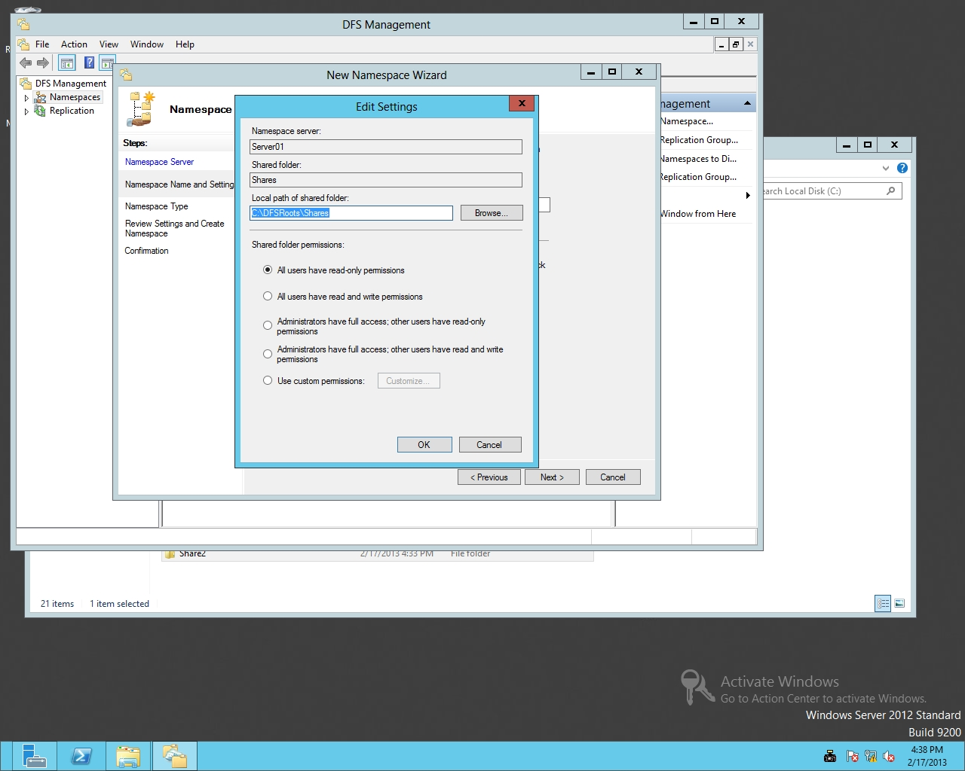

Figure 4-1

Specifying Share permissions for a DFS namespace

|  |  |
| --- | --- |
| Question 2 | What is the default location for the shares folder? C:\DFSRoots\Shares |

**15.** Click *All users have read and write permissions*. Click OK to close the Edit Settings dialog box.

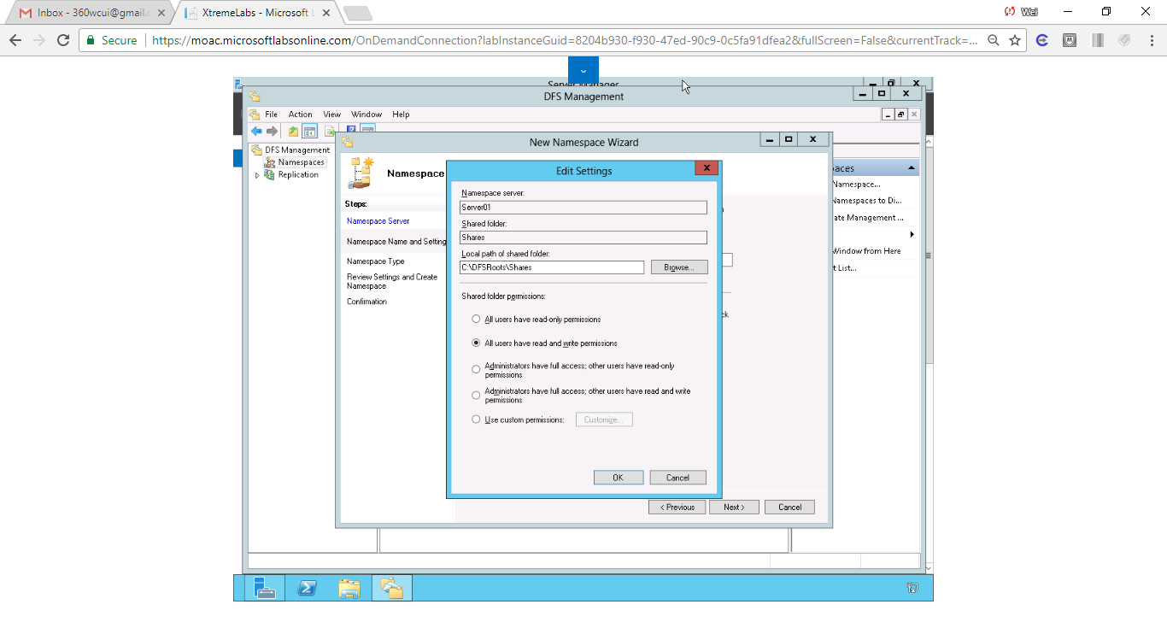

Figure Click All users have read and write permissions. Click OK to close the Edit Settings dialog box.

**16.** On the Namespace Name and Settings page, click Next.

|  |  |
| --- | --- |
| Question 3 | What is the name of the domain-based namespace? |

**17.** On the Namespace Type page, with Domain-based namespace already selected and Windows Server 2008 mode selected (as shown in Figure 4-2) click Next.

|  |  |
| --- | --- |
| Question 4 | What is the advantage of Windows Server 2008 mode? |

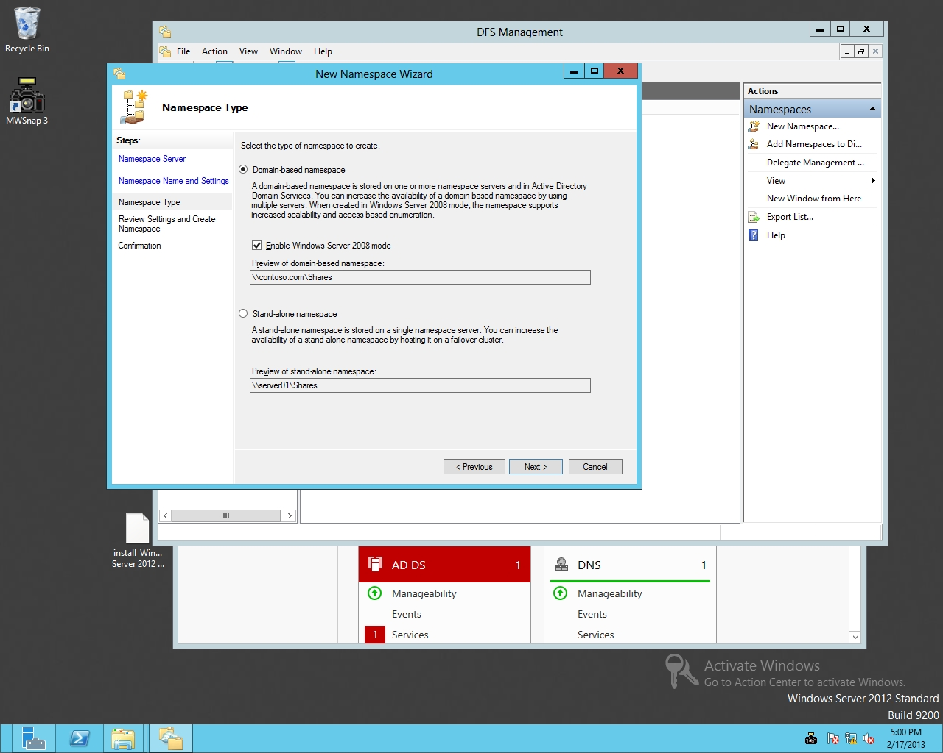

Figure 4-2

Selecting the type of namespace

**18.** On the Review Settings and Create Namespace page, click Create.

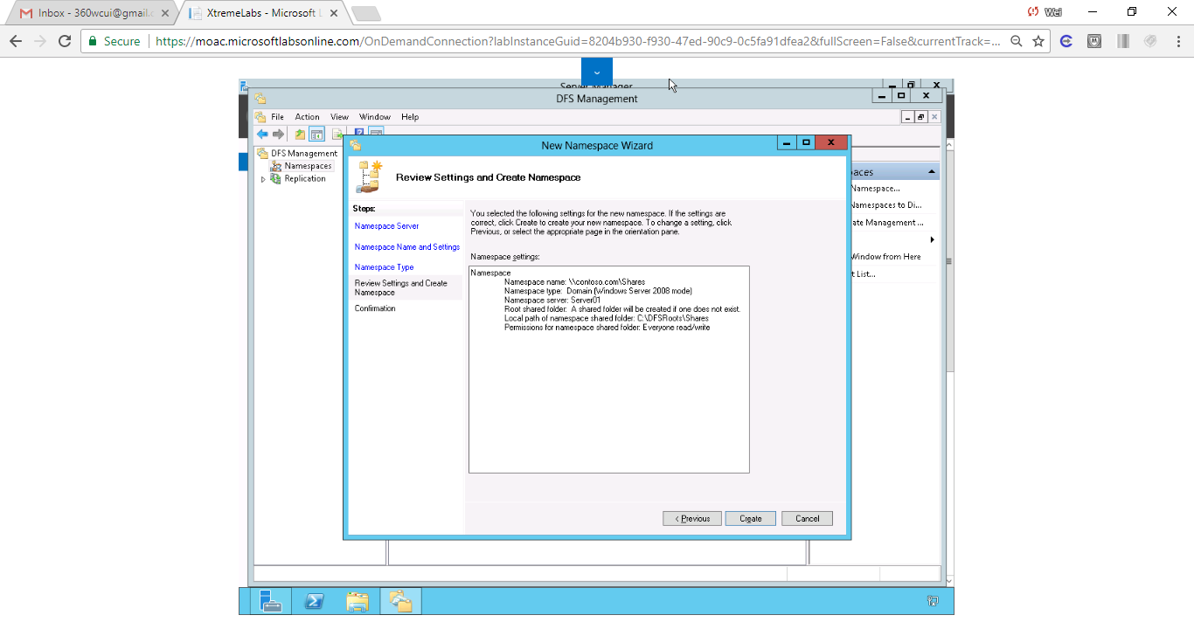

Figure On the Review Settings and Create Namespace page, click Create

**19.** When the name space is created, click the Close button.

**20.** On the DFS Management console, in the left pane, expand the Namespaces node and click \\contoso.com\Shares.

**21.** Under Actions, click New Folder, as shown in Figure 4-3. The New Folder dialog box opens.

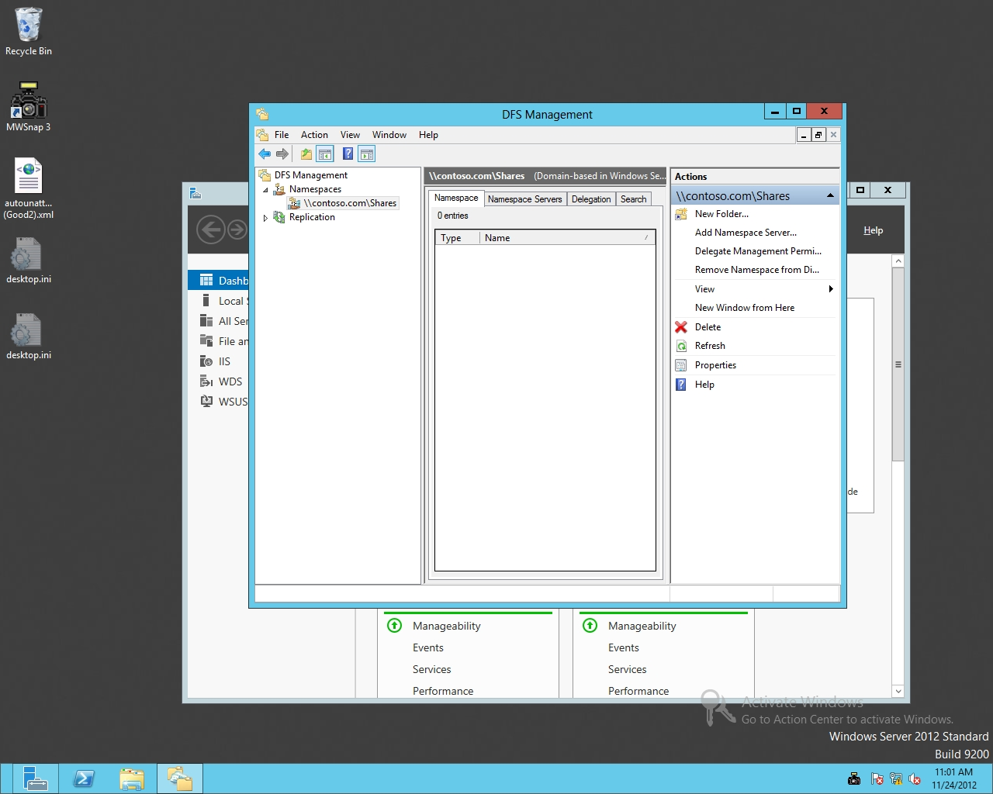

Figure 4-3

The DFS Management console with available actions

**22.** Type **Server01 Share1** in the Name text box.

**23.** To specify the shared folder, click Add.

**24.** In the Add Folder Target dialog box, type **\\Server01\Share1** in the Path to folder target text box. Click OK to close the Add Folder Target dialog box.

**25.** Click OK to close the New Folder dialog box.

**26.** Under Actions, click New Folder. Create a new folder called **Server01 Share2** that points to \\Server01\Share2. Click OK. Click OK, again.

**27.** Under Actions, click New Folder. Create a new folder called **Server02 Share1** that points to \\Server02\Share1. Click OK, twice

**28.** Under Actions, click New Folder. Create a new folder called **Server02 Share2** that points to \\Server02\Share2. Click OK, twice.

**29.** On Server01, open a File Explorer window and type **\\contoso.com\shares** in the location text box and press Enter. See Figure 4-4.

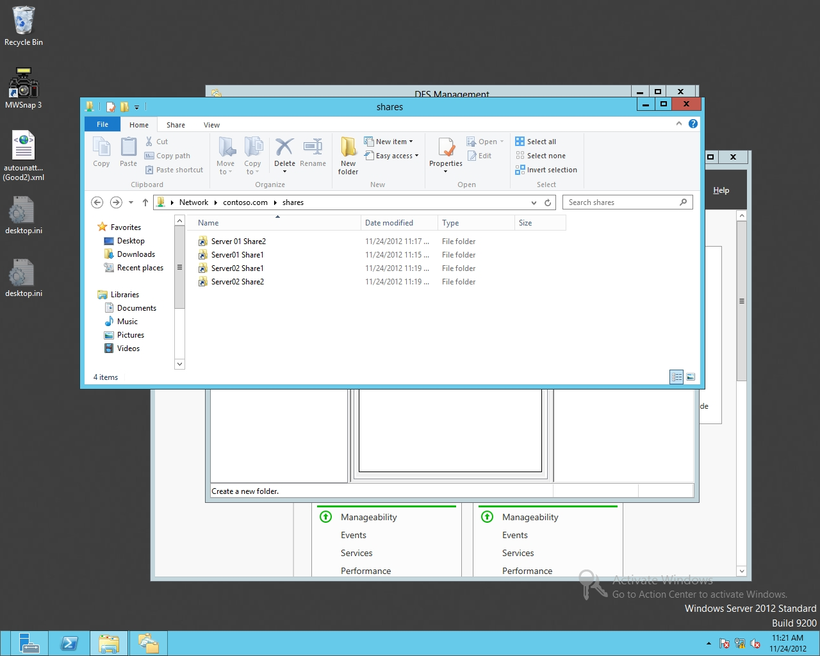

Figure 4-4

Accessing a namespace

**30.** Close File Explorer.

**31.** On the DFS Management console, right-click the\\contoso.com\Shares namespace and click Properties. The Properties dialog box opens.

**32.** Click the Advanced tab.

**33.** Click to select *Enable access-based enumeration for this namespace*.

**34.** Take a screen shot of the \\contoso\com\Shares Properties dialog box by pressing Alt+Prt Scr and then paste it into your Lab04_worksheet file in the page provided by pressing Ctrl+V.

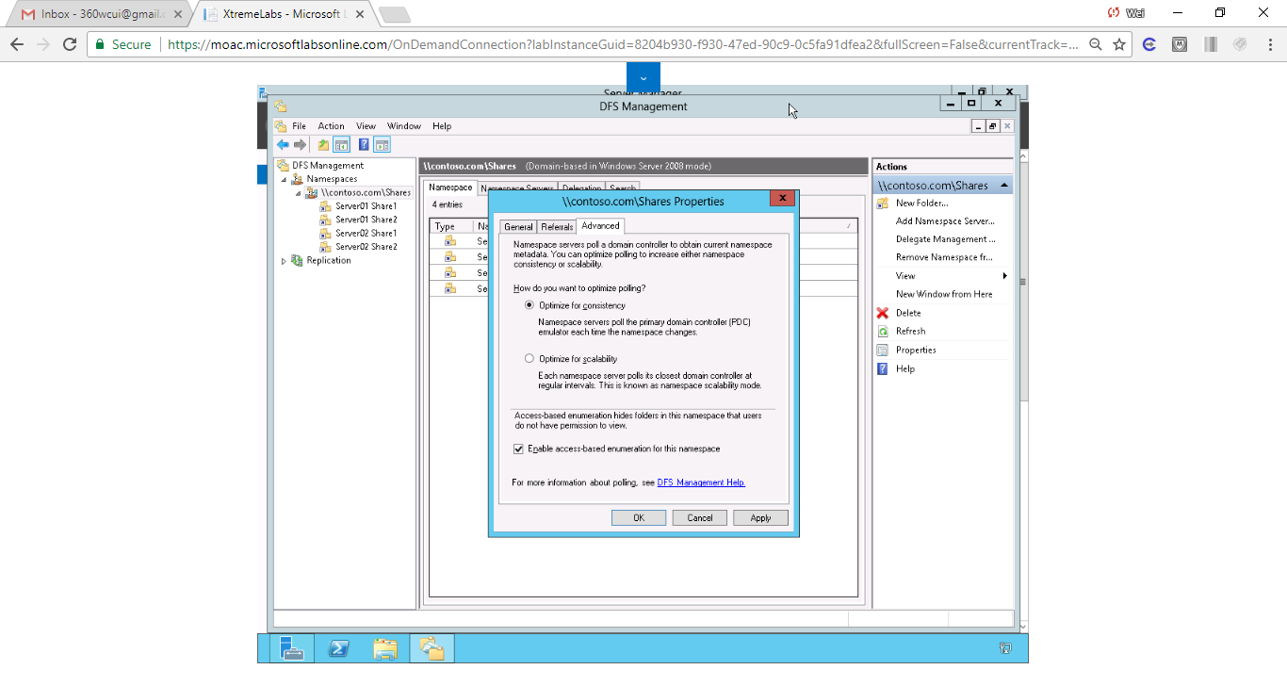

Figure Click to select Enable access-based enumeration for this namespace.

|  |  |
| --- | --- |
| Question 5 | What does the Enable access-based enumeration for this namespace option do? Access-based enumeration hides folders in this namespace that users do not have permission to view |

**35.** Click OK to close the Properties dialog box.

**Lab Summary**

During this exercise, I created several shared folders and linked them together with DFS Namespace. DFS Namespace is technology used to create a shared folder of shared folders.

1. In Exercise 4.2, where is the configuration for domain-based namespaces stored?

According to Microsoft Support “ The following locations store different configuration data for the Distributed File System (DFS) Namespaces: •

Active Directory Domain Services (AD DS) stores domain-based namespace configuration data in one or more objects that contain namespace server names, folder targets, and various other configuration data. •

The namespace servers maintain shares for each namespace hosted.

The registry keys on the domain-based namespace servers store namespace memberships.

Note On the stand-alone namespace servers, registry keys store all the namespace configuration data.

1. In Exercise 4.2, what technology is used to automatically copy files from one server to another?

Domain shares